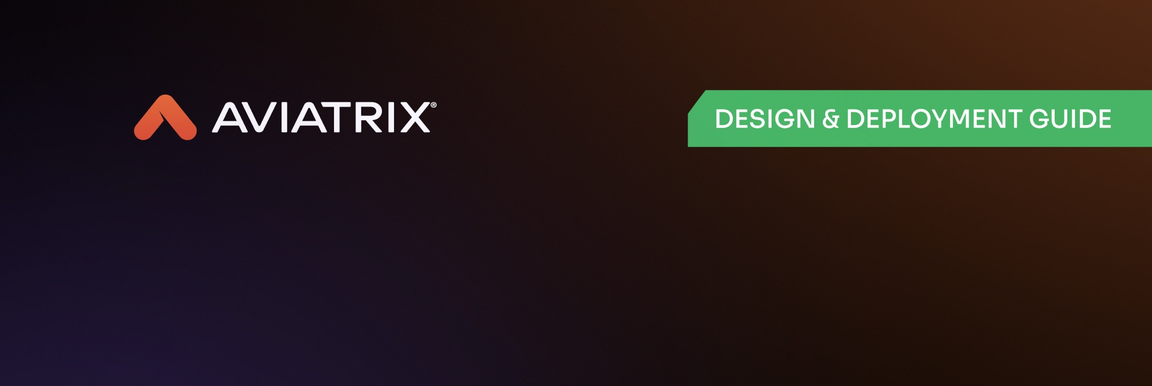
Aviatrix Distributed Cloud Firewall Rule Configuration Guide
Design Guide

Preface 1
Guide Types 2
Disclaimer 2
Getting the Latest Versions 2
Purpose of This Guide 2
Audience 2
Introduction 3
Distributed Cloud Firewall Architecture Overview 4
Kubernetes Enforcement 4
Key Aviatrix Concepts 5
Aviatrix Gateway 6
Public Subnet Filtering Gateway 6
Gateway Sizing Requirements 6
Distributed Cloud Firewall Scaling 7
Feature Maturity 9
Feature Maturity in 8.1 9
Logging best practices 11
Distributed Cloud Firewall Logging Locations 12
Logging and Aviatrix Security Score 13
Distributed Cloud Firewall Log Patterns 13
Layer 3 / Layer 4 Rule Pattern 13
FQDN Rule Pattern 14
TLS Decrypted Rule Patterns 15
Intrusion Detection Log Patterns 16
Aviatrix Distributed Cloud Firewall Concepts 17
Smart Groups 18
External Groups 19
Web Groups 20
Kubernetes Clusters 21
The Cloud Asset Inventory 22
Optional Rule Settings 22
TLS Decryption 23
CSP Specific Enforcement 25
Distributed Cloud Firewall Rule Concepts 26
Aviatrix Secure Egress 28
External Connections 29
Security Group Orchestration (Azure) 30
Network Address Translation and DCF 35
Source NAT (SNAT) 36
Destination NAT (NAT) 37
Layer 7 Filtering 38
Additional Layer 7 features 41
SNI Verification 41
Ensure TLS 43
TLS Decryption 44
Distributed Cloud Firewall Policy Best Practices 47
Brownfield Migration Pattern 48
Approach 1: Enabling logging on Greenfield Rule 49
Approach 2: Specific per-environment rule (safer approach) 49
Terraform Deployment 50
Firewall Migration 51

Preface

Guide Types

Overview guides offer high-level introductions to technologies or concepts with an emphasis on business value.
Solution guides provide introduction to product capabilities for using Aviatrix to provide visibility, control, and protection to applications built in a specific environment. These guides describe the technologies providing examples and should be considered required reading prior to using their companion design & deployment guides.
Design & Deployment guides provide definitive guidance for different deployment scenarios, as well as procedures for combining Aviatrix technologies with third-party technologies in an integrated design. To ensure the design is reproducible, these guides provide Terraform templates for deployment of Aviatrix & third-party vendors such as CSPs. Will include best practices recommendations.

Disclaimer
The guides occasionally describe products from other companies. While the steps and screenshots were accurate at the time of publication, those companies may have since updated their user interfaces, processes, or requirements. Please refer to the external vendor website for latest documentation.

Getting the Latest Versions
Access the latest reference architecture guides at: https://www.aviatrix.com/architecture

Purpose of This Guide
This guide explains how to model Aviatrix

Audience
This guide is for technical readers, including system architects and design engineers, who are plan to or currently leveraging Aviatrix Cloud Firewall to build and enforce security policies. This guide assumes the reader is familiar with the basic concepts of applications, networking, security, and high availability (HA). The reader should also possess a basic understanding of network and hybrid cloud architectures. To be successful, you must have a working knowledge of Aviatrix platform.

Introduction
The Aviatrix Distributed Cloud Firewall (DCF) is a core component of a Cloud-Native Security Fabric (CNSF), designed to embed inspection and enforcement directly into the path of traffic. Unlike legacy models that rely on "bolted-on" security, DCF is cloud-integrated and workload-aware, allowing security to scale natively with your applications. By enforcing security directly within the network fabric, it ensures a consistent and invisible layer of protection across the entire hybrid cloud estate.
This implementation guide functions as a strategic resource to bridge the gap between DCF concepts and technical execution. It provides the architectural blueprints and configuration standards necessary to deploy a distributed security posture across common enterprise scenarios.

Distributed Cloud Firewall Architecture Overview
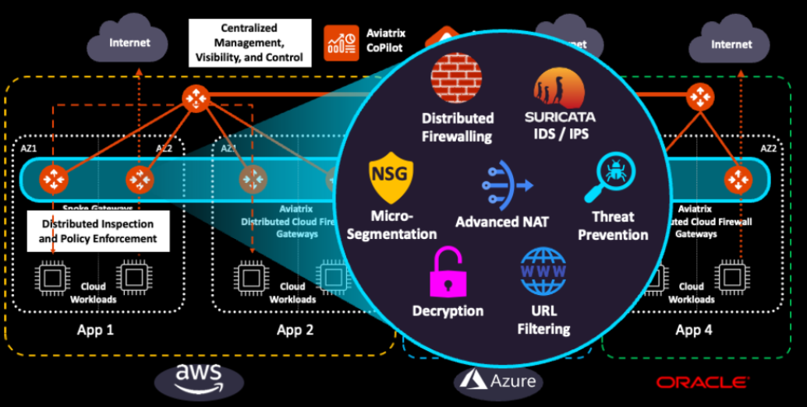

Key DCF Terms
To effectively implement a fabric-based security model, it is essential to understand the core components that shift security from static, IP-based rules to dynamic, intent-based policies.

1. SmartGroups
SmartGroups are the fundamental building blocks of DCF policies. Instead of defining a rule for a specific IP address, you create a logical grouping based on real-time metadata.
- Definition: A dynamic container that groups workloads based on attributes like Cloud Tags, VPC/VNet IDs, Subnets, or Kubernetes Namespaces.
- The Value: When a new workload is spun up with a specific tag (e.g., Env: Production), it is automatically added to the corresponding SmartGroup and inherits all associated security policies.

2. Intent-Based Policy
This is a shift in how security is expressed, moving from network plumbing to business logic.
- Definition: A policy that defines "what" should happen rather than "how" the network is routed. For example: “Allow the Web-Tier to talk to the App-Tier.”
- The Value: You write the policy once in plain language (using SmartGroups), and the Aviatrix fabric handles the complex translation into the underlying cloud-native constructs across AWS, Azure, and OCI.

3. Distributed Enforcement
This refers to the architectural placement of the firewall.
- Definition: Rather than hair-pinning traffic to a centralized virtual appliance (a "chokepoint"), enforcement occurs at the Aviatrix Gateway closest to the source of the traffic.
- The Value: It eliminates the "tromboning" effect, reducing latency and data transfer costs while ensuring there are no blind spots in east-west or egress traffic.

4. Policy as Code (PaC)
This is the operationalization of security using DevOps principles.
- Definition: Managing security rules through machine-readable definition files (typically Terraform/HCL) rather than manual GUI configurations.
- The Value: It allows security to be version-controlled, peer-reviewed via Pull Requests, and deployed through the same CI/CD pipelines as your application code.

5. Cloud-Native Security Fabric
The "Fabric" is the underlying mesh of Aviatrix Gateways that connects your multi-cloud environment.
- Definition: An intelligent network layer that is globally aware of all routes, workloads, and security states.
- The Value: Because the firewall is "baked into" the fabric, security becomes an inherent property of the network. If the network exists, the security is already there.

6. Kubernetes (K8s) Awareness
This term refers to the fabric's ability to "see" inside containerized clusters.
- Definition: The integration that allows the DCF to identify traffic at the Pod and Namespace level, rather than just the VM (Node) level.
- The Value: It provides granular micro-segmentation for containerized apps without requiring the overhead of a service mesh like Istio.

Kubernetes Enforcement
The Aviatrix Cloud-Native Security Fabric extends the same Distributed Cloud Firewall (DCF) capabilities from virtual machines directly into containerized environments. By onboarding Kubernetes clusters, you bridge the visibility gap between traditional network-layer security and modern, ephemeral microservices.
Caveat for Existing Customers: It is important to note that Kubernetes onboarding is in addition to our standard Cloud Account onboarding. While your AWS, Azure, GCP, or OCI accounts are already connected to the Controller, the Kubernetes clusters within those accounts require a separate, secondary onboarding process to enable deep pod-to-pod visibility and namespace-aware policies.

Onboarding Workflow

1. Cluster Discovery & Credentialing
The first step involves providing the Aviatrix Controller with the necessary permissions to interact with your cluster's API server. This allows the fabric to "discover" the internal topology of the cluster.
- EKS/AKS/GKE/OKE Support: Supports managed Kubernetes services across all major providers.
- Service Account Creation: A dedicated Service Account is typically used to provide the Controller with read-only access to K8s metadata (Namespaces, Pods, and Services).

2. Fabric-to-Cluster Integration
Once discovered, the Aviatrix Controller maps the Kubernetes constructs to its internal SmartGroup engine.
- Metadata Sync: The Controller begins syncing real-time data about pods, namespaces, and labels.
- No Sidecars Required: Unlike a service mesh, this onboarding does not require injecting sidecar proxies into your application pods or modifying your deployment manifests.

3. Defining Kubernetes-Aware SmartGroups
After onboarding, you can create security policies that use Kubernetes-native attributes as the source or destination.
- Namespace-Based Rules: ALLOW [Namespace: Production] → [Namespace: Shared-Services].
- Label-Based Rules: DENY [Label: Role=Frontend] → [Label: Role=Internal-DB].
- Hybrid Policies: Create rules that allow a specific K8s Namespace to communicate with a legacy database running on a traditional VM or an external SaaS endpoint.

Technical Value for SecDevOps
- Consistent Governance: Manage VM and Container security from a single, unified policy plane.
- Pod-to-Pod Visibility: View internal cluster traffic flows in Aviatrix CoPilot, identifying lateral movement that traditional firewalls cannot see.
- Policy as Code: Onboarded clusters can be managed via the Aviatrix Terraform provider, allowing cluster security to be defined alongside the cluster's infrastructure code.

Deployment tip: DCF filtering of Kubernetes traffic occurs at the Aviatrix gateway. It is recommended to disable NAT in the Kubernetes cluster to allow filtering of individual PODs. In AWS this can be done by enabling AWS_VPC_K8S_CNI_EXTERNALSNAT

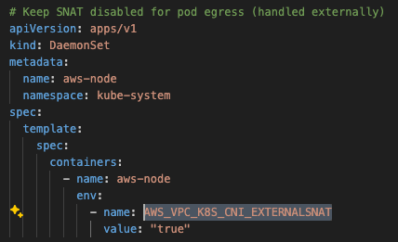

Gateway Sizing Requirements
When configuring a security posture with Aviatrix, the first consideration is ensuring the correct gateway sizing. The ability to access various DCF capabilities depends upon proper sizing of Aviatrix gateways enforcing the firewall ruleset.
Aviatrix CoPilot will alert in the event gateway sizing's may be in-adequate for the configured rule features.

Cloud | L4 Only | L4 w/ External Groups | L7 w/ TLS Decrypt only | L& w/TLS Decrypt + IDS
AWS | t3.micro (non-production) | t3.medium or larger | t3.small | t3.medium
Azure | Standard_B1ms | Standard_B2ms | Standard_B1ms | Standard_B2ms
GCP | n1-standard-1 | n1-standard-2 | n1-standard-1 | n1-standard-2

*Consult Aviatrix online documentation for up-to-date sizing recommendations.
Alerts will be visible in system messages the event a configured policy is unable to be enforced due to incorrect gateway sizing.

Example System Message:

Distributed Cloud Firewall Scaling
In addition to reviewing the proper sizing of Aviatrix gateways, it’s important to be mindful of scaling values when creating a security posture. These current limits (as of 8.1) are sufficient to cover most environments – and are regularly being increased.

Capability | 6.8 | 6.9 | 7.0 | 7.1 | 7.2 | 8.0 | 8.1
Number of SmartGroups | 500 | 500 | 500 | 500 | 1,200 | 1,200 | 1,200
Number of Domains per WebGroup |  |  |  | 3,000 | 3,000 | 3,000 | 3,000
Number of CIDRs per Group | 3,000 | 3,000 | 3,000 | 3,000 | 10,000 | 10,000 | 10,000
Total Number of CIDRs |  |  | 10,000 | 10,000 | 300,000 | 300,000 | 300,000
Number of DCF Rules | 2,000 | 2,000 | 2,000 | 2,000 | 5,000 | 5,000 | 5,000

*Consult Aviatrix online documentation for up-to-date values.

Feature Maturity
Aviatrix Distributed Cloud Firewall is under heavy active development with new features being released in every software release. Consult the documentation for current capabilities and scaling numbers. Preview features are not meant for use in PRODUCTION environments, but users are encouraged to deploy in their DEV environments and provide feedback.

Feature Maturity in 8.1
GA Features in 8.1
Layer 4 Rules
Rules with Domain WebGroups
Rules with ExternalGroups (formerly GeoGroups and ThreatGroups)
DCF on Public Subnet Filtering Gateways
DCF on Site2Cloud (L4 only on Transit)
DCF Rulesets
Layer 4 logging (+Domain)
Log export via Syslog
SmartGroups (VM/VPC/Subnet)
DNS Hostname SmartGroups
Domain WebGroups
ExternalGroups (includes Threat Feeds and Countries)
SmartGroups (S2C)
Security Group Orchestration (Azure)

Preview Features in 8.1
DCF on Edge Spoke (L4)
DCF on Edge Transit S2C (L4)
Rules with URL WebGroups
DCF on Transit Egress
Security Group Orchestration (non-Azure)
Transparent TLS Decryption
Suricata IDS (Egress only)
Dynamic Signature Update
Import Decryption Certificate
IDS/IPS logging
Kubernetes SmartGroups (Workloads and Nodes)
URL WebGroups
SNI Verification (valid with WebGroups)
SaaS-Based Services (Azure and GitHub)

Logging best practices
Aviatrix CoPilot provides visibility for rule matches, but it is recommended to configure your SIEM as a destination for Aviatrix logs. Syslog destinations will receive all Aviatrix logs, which include IPSEC messages, Controller and Copilot login information and activity, Distributed Cloud Firewall events, and more. Filtering of unwanted messages can be performed at forwarding points - for example at High Volume Forwarders (HVFs) when using Splunk, or by insertion of the Aviatrix Log Integration Engine.
For example patterns in regex format, consult the Log Integration Engine configuration.

Distributed Cloud Firewall Logging Locations
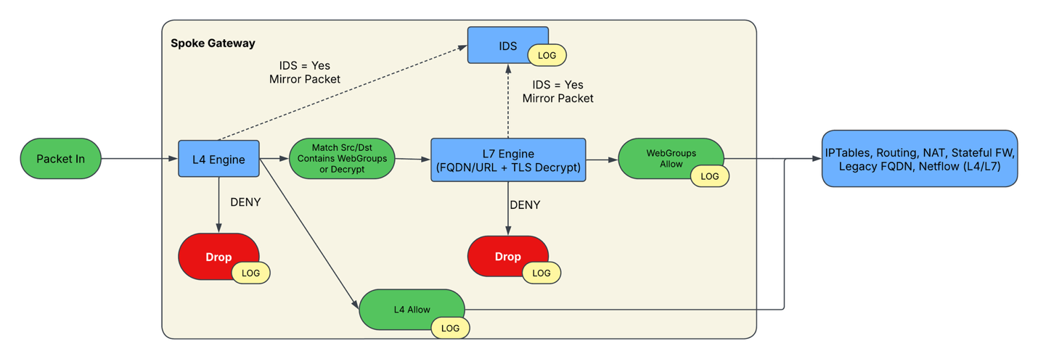
DCF Logging occurs at various locations in the internal engines. Of note, if a Layer 7 (WebGroup based rule) exists as well as a L4 rule in watch mode, the log message itself will show the L4 rule being actually handled in the L7 engine. Once a packet is sent to the L7 engine, it will handle reporting that traffic.

Logging and Aviatrix Security Score

@todo: Here we cover how Aviatirx logging is used with Aviatrix Security Score
Additional info: https://aviatrix.atlassian.net/wiki/spaces/AVXPM/pages/2796912679/Egress+Score+v1+Alghorithm

Distributed Cloud Firewall Log Patterns
Aviatrix DCF lo formats vary based upon the type of log (L3/L4 rules, IDS enabled rules, FQDN rules, etc.). The following tables detail the rule patterns that are currently in use, as of Controller version 8.1.

Layer 3 / Layer 4 Rule Pattern
Field | Example | Meaning | Notes / Format
PRI | <158> | Syslog PRI (facility×8 + severity). | 158 ⇒ facility 19 (= local3), severity 6 (= informational). RFC 3164/5424.
Timestamp (BSD) | Oct 14 16:17:23 | Syslog header timestamp. | Local time, no year/timezone (BSD syslog style).
Host | GW-m80-dummy-injecter-4.153.186.176 | Reporting host/device name. | Often hostname or instance ID; includes an IP suffix.
Process / App | /usr/local/bin/avx-gw-state-sync | Program that emitted the log. | Full path shown here.
Timestamp (ISO) | 2025/10/14 16:17:23 | App-provided timestamp inside message body. | Redundant but precise (includes year).
Tag | AviatrixGwMicrosegPacket | Component/record type. | Aviatrix microsegmentation packet log.
POLICY | 159d7111-e4ea-46c1-9ff1-7fa356a51224 | ID of the matched microseg policy/rule. | UUID; lets you cross-reference the policy definition.
SRC_MAC | c0:d6:82:82:f0:cd | Source L2 MAC address. | aa:bb:cc:dd:ee:ff.
DST_MAC | 7c:1e:52:97:da:d1 | Destination L2 MAC address. | aa:bb:cc:dd:ee:ff.
IP_SZ | 60 | Total IPv4 packet length in bytes. | Includes IP header + TCP/UDP header + payload.
SRC_IP | 10.48.0.5 | Source IPv4 address. | Usually workload/instance IP.
DST_IP | 192.168.154.1 | Destination IPv4 address. | Remote workload or gateway.
PROTO | TCP | L4 protocol. | Common: TCP/UDP/ICMP.
SRC_PORT | 33772 | Source transport port. | Ephemeral client port.
DST_PORT | 80 | Destination transport port. | Service port (HTTP here).
DATA | 0x | Hex dump of payload (if present). | 0x with nothing after it implies no payload captured (e.g., a TCP SYN) or logging set to omit payloads.
ACT | DENY | Enforcement action taken by the microseg policy. | Others could be ALLOW, DROP, REJECT, etc., depending on product.
ENFORCED | true | Whether the action was actually applied (vs. just observed). | true = enforced on dataplane; false is not.

FQDN Rule Pattern
Field | Example | Meaning | Notes
PRI | <158> | Syslog PRI (facility×8 + severity). | 158 ⇒ facility 19 (= local3), severity 6 (= informational). RFC 3164/5424.
Timestamp (BSD) | Oct 14 16:17:23 | Syslog-style timestamp from the log header. | BSD format (no year/tz).
Host | gw-us-east1-a | Aviatrix gateway that emitted the event. | May include dashes/region suffixes.
sip | 10.48.0.5 | Source IP of the flow being evaluated. | IPv4/IPv6 supported by %{IP}.
dip | 192.168.154.1 | Destination IP of the flow. | IPv4/IPv6.
hostname | api.github.com | FQDN/hostname the traffic targets (post-FQDN match). | Often the resolved SNI/HTTP host.
state | ALLOW / DENY | Decision by the FQDN policy engine. | Typically ALLOW/DENY; casing may vary.
drop | policy / tls / dns | Reason for drop when state is deny. | Only present in some patterns (see matrix).
rule | corp-allow-github | Matched FQDN rule name/ID. | Only present in some patterns; RULE is a custom pattern (see below).

TLS Decrypted Rule Patterns
Field | Example | Meaning | Notes
PRI | <158> | Syslog PRI (facility×8 + severity). | If you want to keep it as an int, change to ^<%{NUMBER:pri:int}>.
Timestamp (BSD) | Oct 14 16:17:23 | Upstream/prepended BSD timestamp from a relay. | Entire group optional; present when a relay adds its own header.
Host | relay-203.0.113.9 | Host that added the preamble. | Comes from %{HOSTNAME}-%{IP} before literal syslog.
Timestamp (BSD) | Oct 14 16:17:23 | Primary event timestamp. | You’re matching it but not naming it. If you want it, change to %{MONTH} +%{MONTHDAY} +%{TIME:date} or %{SYSLOG_TIMESTAMP:date}.
gw_hostname | east1-a | Gateway name following the GW- prefix. | Literal GW- included in the log, not captured.
gw_ip | 10.48.0.5 | Emitting gateway IP. | Hyphen-delimited with the hostname: GW-<host>-<ip>.
app | traffic_server | Application tag. | Literal string.
pid (optional) | 1234 | Process ID when present. | Whole bracketed PID and colon are optional.
json_payload (stored in metadata) | {"msg":"...", "src":"...", ...} | The remainder of the line, expected to be JSON. | Captured into [@metadata] so it won’t index as a field by default; send it to a JSON filter next.

Intrusion Detection Log Patterns
Field | Example | Meaning | Notes
pri | <158> | Syslog PRI (facility ×8 + severity). | Same as earlier: e.g., 158 ⇒ local3/info.
Timestamp (BSD) | Oct 14 16:17:23 | Optional BSD-style date that may precede the main timestamp. | Entire parenthesized group is optional. Often present if a relay prepends its own header.
Host | relay-203.0.113.9 | Host that added the preamble. | Format: %{HOSTNAME}-%{IP} before literal syslog.
Timestamp (BSD) | Oct 14 16:17:23 | Primary BSD syslog timestamp for the event. | No year/timezone. Use device timezone when normalizing.
gw_hostname | gw-east1-a | Emitting gateway/device logical name. | Immediately followed by -%{IP}.
gw_ip | 10.48.0.5 | Emitting gateway/device IP. | Hyphen-delimited with hostname.
app | suricata | Application tag. | Literal string.
pid (optional) | 1234 | Suricata process ID when present. | Whole [1234]: is optional; if absent there’s just a single space after suricata.
suricataData | … | The rest of the Suricata message payload. | Typically JSON (eve.json line) or key/val. Parse downstream (JSON/k-v).

Aviatrix Distributed Cloud Firewall Concepts
Aviatrix DCF rulesets are based off a concept called “Groups”. Groups are versatile constructs that provide simplified management of resources across subscriptions, cloud accounts, regions, and VPC/VNets. They are reusable and support seamless querying for diverse Aviatrix features. While some groups focus on filtering and securing internet-bound traffic, others aid in threat protection, provide geographical context for implementing location-based policies, or provide access to SaaS-based services such as Azure and GitHub. Together, these groups offer a comprehensive solution for resource organization, security, and management within Aviatrix deployments.
The available types of groups are:
- Smart Groups
- External Groups
- Web Groups

Smart Groups
Smart Groups provide the ability to match various types of cloud resources:
Smart Group Type | Matches | How it works
Virtual Machine | Properties and Tags | This resolves VMs to IP addresses.
Subnet | Properties and Tags | This resolves subnets to IP addresses.
VPC/VNETs | Properties and Tags | This resolves VPC/VNETs to IP addresses
IPs/CIDRs | IPs and CIDRs | This uses defined IP addresses.
DNS Hostnames | DNS Hostnames as resolved by aviatrix gateway. | Ensure you set the server for hostname resolution.
External Connections | Aviatrix External Connection | External Connections currently only support routed connections
Kubernetes Workloads | Cluster, Namespace, or Service | This resolves IP addresses by querying the K8s cluster. Traffic must egress the cluster for filtering.
Kubernetes Nodes | Name or Cluster | This resolves IP addresses by querying the K8s cluster. Traffic must egress the cluster for filtering.

External Groups
External Groups provide the ability to match based on external feeds - lists of IP ranges published by organizations like Azure and Proofpoint which represent services, threats, and more. External groups are regularly refreshed with previous versions cached.
External Group Type | Matches | How it works
Countries | IP CIDRs for IANA regions | MaxMind published GEOlocated IP ranges.
Azure Services | Azure defined IP blocks for various services. | Azure publishes IP ranges for services. Does not apply to private endpoints.
Github Services | Github defined IP blocks for various services | Github published IP ranges for various services.
ThreatGroups | IP addresses published by Proofpoint. | Proofpoint classifies IPs by threat category and severity. Aviatrix allows for granular filtering based upon this.

Web Groups
Web Groups provide the ability to match on web properties like domain names and URL paths:
Web Group Type | Matches | How it works
Domains | Domain Names | Matches are done based upon SNI information, HTTP hostnames, and (if TLS decryption is enabled) HTTP hostnames inside of HTTP requests. Use “*” as a prefix wildcard, which will match multiple levels of subdomains. Wildcards can also be used to match all TLDs or even portions of domain names.
URLs | URL patterns | Filters based on HTTP request and (if TLS decryption is enabled) HTTP hostnames inside of HTTP requests. Wildcards (*) may also be used in both hostname and URLs.

Unlike Layer 3 / Layer 4 based rules, web group based rules are stateful. As such, only use them on rules relating to egress traffic from VPC to Internet. Aviatrix Spoke VPCs can enable this direct-to-internet ability in Copilot under Security/Egress.
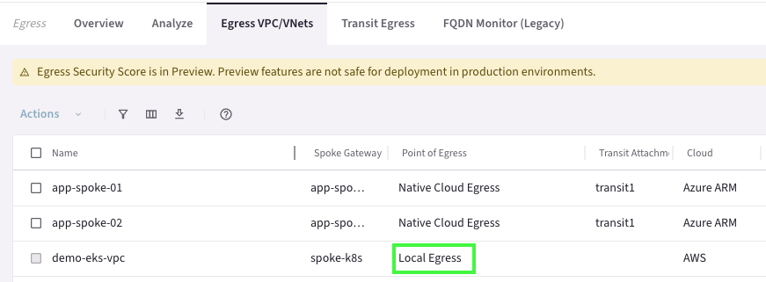

Kubernetes Clusters
Kubernetes clusters are onboarded to DCF via Cloud Assets. Once on-boarded, Aviatrix will identify namespaces, services and pods which can be used in DCF smart groups and rules.
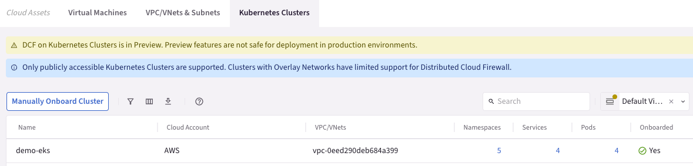

The Cloud Asset Inventory
The Cloud Asset Inventory is an important feature of DCF. The Cloud Aaset Inventory (CAI) is a live inventory of all virtual machines, VPCs/VNET, subnets, Kubernetes Clusters, and more that Aviatrix has discovered in your environment. The inventory captures a large number of attributes about the environment, including IP addresses, tags, regions, etc.
Important information including which Smart Groups the object belongs to is clearly visible.
This inventory is available for viewing in CoPilot under Cloud Resources/Cloud Assets.
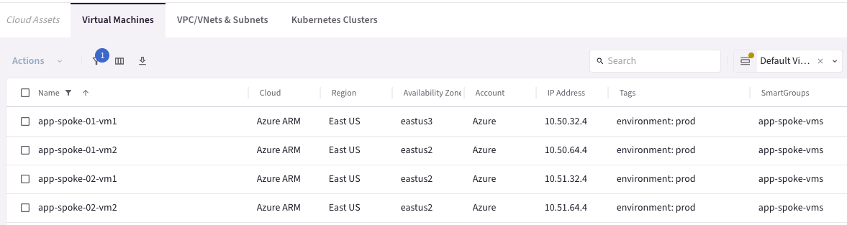

Optional Rule Settings
When configuring rulesets, there are optional settings one should be aware of. These govern how rules are enforced:
Setting | Purpose | Enforcement Location | Caveat
Enforcement | This allows rules to be installed but not acted upon. This will provide logs without interrupting traffic flow and can be used as a diagnostic tool to help model firewall rules. | Aviatrix Gateway | Rule processing continues after matching a non-enforced rule. This allows one to test a rule in non-enforced mode, while still enforcing a rule that appears later in the priority list.
Logging | Toggles the logging of any matching hit. Logs are sent to Aviatrix CoPilot and any configured syslog recipient (SIEM, etc) | Aviatrix Gateway | Logging should be enabled responsibly, and noisy traffic (security scanners, etc) should be omitted from logging.
Security Group Orchestration | Enable this feature on a rule if you want the rule to be enforced INSIDE of the VPC between virtual machines. | Cloud specific security groups applied to the network interface of VMs. In Azure, this leverages application security groups. | Filters only VM based traffic, does not apply non-VM traffic (like Lamba functions, private endpoints, load-balancers, etc)
Ensure TLS | Enforces the use of TLS on any traffic matching this rule. | Aviatrix Gateway | If TLS is not present, traffic is dropped.
TLS Decryption | Decrypt before inspection of traffic. | Aviatrix Gateway | Requires CA certificates to be installed on workloads.  Only to be used on egress traffic.
Intrusion Detection | Inspect traffic for known malicious or questionable signatures. | Aviatrix Gateway | Currently, IDS rules cannot be customized.

--

TLS Decryption
When planning to perform deep packet inspection, it is best practice to replace the default Aviatrix decryption CA certificates with CA certificates specific to your organization. This CA must be trusted by any workloads that will have their traffic inspected – meaning it will need to be installed on the workloads themselves as a trusted entity.
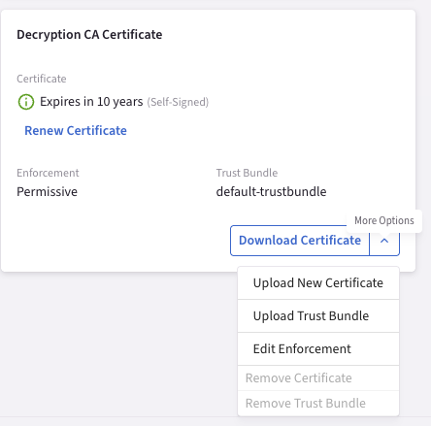

TLS decryption also has 3 settings relating to the trust of the upstream server. “Strict” will terminate sessions if the upstream certificate chain is not validated. “Permissive” will allow access but generate a log message, while “Ignore” will accept and not generate a log.

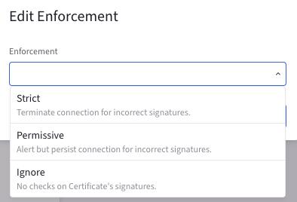
TLS decryption and web group filtering only applies to TCP:443 (HTTPS) traffic. When creating rules ensure traffic matches these ports.

CSP Specific Enforcement

Aviatrix provides the ability to enable and disable DCF on specific cloud providers by customizing “Enforcement on Clouds” in the Distributed Cloud Firewall settings. By default, AWS, Azure, GCP are enabled (including their GovCloud counterparts). As of 8.1 this only supports CSP based exclusion.
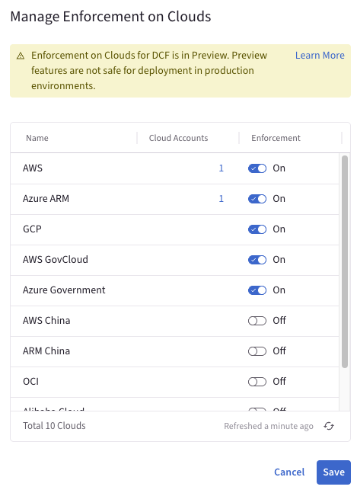

Distributed Cloud Firewall Rule Concepts
Rules are applied in the forward direction pre-NAT and are typically stateless (with the exception of source NATed and web filtered traffic). Rules are enforced on a first enforced match basis. Care is taken, however, to preserve directional access based on destination ports, TCP flags, and ICMP type/response.
For example, the following Layer 4 rule allows traffic originating from APP1 to APP2, but not originating from APP2 to APP1.
Rule Example:
Flow Example: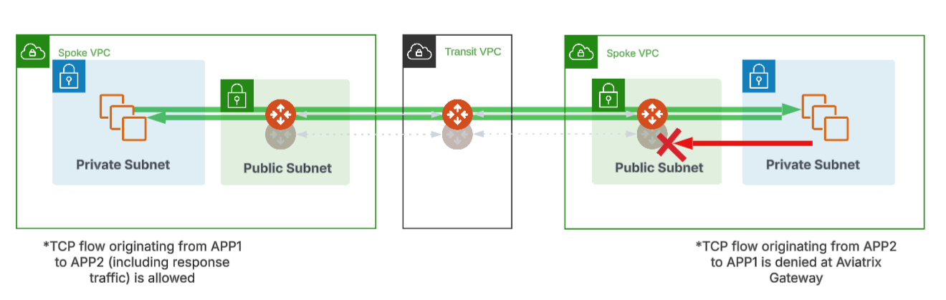
As stated earlier, as with any firewall the rules apply in a first enforced basis. For example, if the firewall policy contains a priority 0 rule which whitelists all traffic to the address range for the Aviatrix website and a priority 10 rule which blocks traffic to *.aviatrix.com, the traffic is allowed due to matching the first rule.
Smart Group for aviatrix_com_address_range:
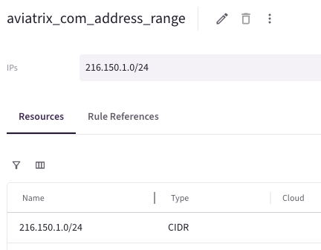
Web Group for aviatrix.com:
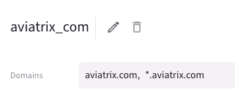
Example Ruleset:
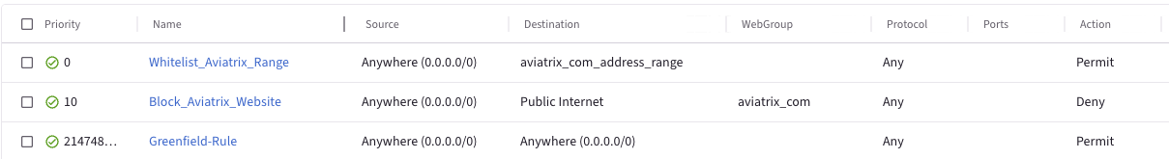

Aviatrix Secure Egress
Aviatrix provides the ability to directly egress to the Internet from select VPC/VNETs in a low-latency, secure manner. Secure Egress can be enabled from Copilot (Security/Egress VPC/VNETS). CoPilot clearly denotes if traffic from a VPC is locally egressing to the Internet or using the Native Cloud point of Egress (for instance, NAT Gateways) or by means of a Centralized Aviatrix Transit Firenet.
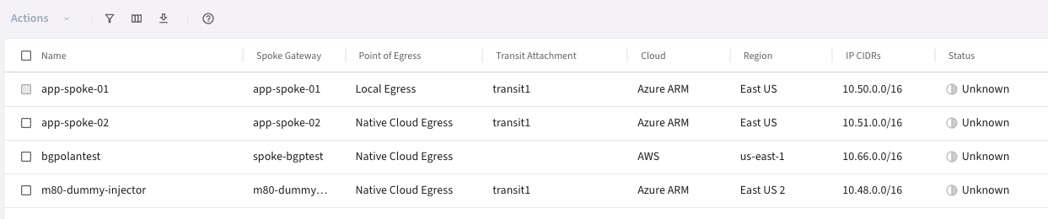
After enabling Aviatrix Secure Egress, the next step is to configure appropriate rules specifying allowed and disallowed traffic. These rules are covered in the following sections along with recommended configurations and best practices.

External Connections
Aviatrix Distributed Cloud Firewall can filter traffic for external connections (for example, VPN connections to 3rd parties). This is achieved by creating an External Connection based smart group for use as either a source or destination in a DCF rule.
Example:
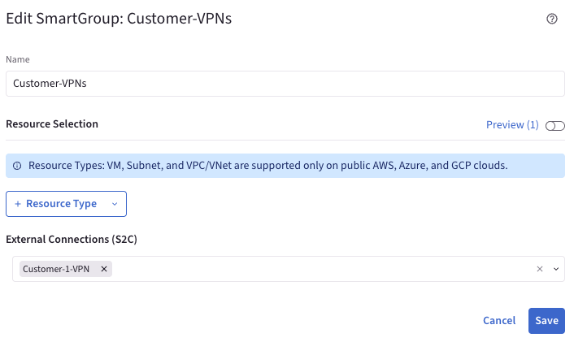
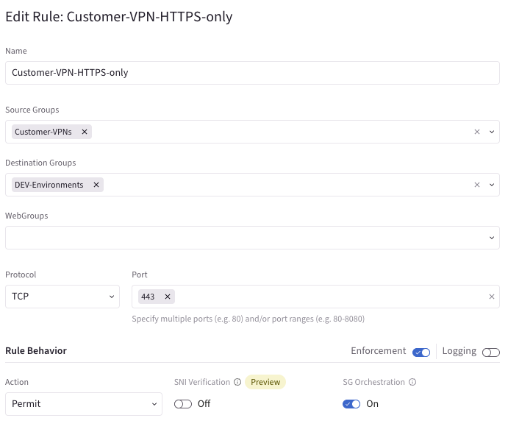

Security Group Orchestration (Azure)
Security Group Orchestration (SGO) applies cloud native security constructs (Access Control Lists) to the subnet NSGs and network interfaces of Virtual Machines. Security Group Orchestration only applies to Virtual Machines and subnets inside of a VNET (or to the VNET as a whole).
With Azure Virtual Machines, Aviatrix performs this is by orchestrating the Application Security Groups feature. Application security groups (ASGs) provide a means to classify an application by tag and establish rules that are based on roles instead of IP addresses. A Virtual Machine may have multiple ASGs assigned to it.
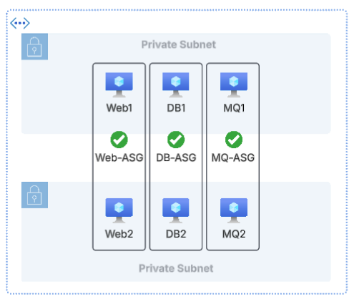
When related to a subnet, Aviatrix orchestrates Network Security Groups attached to the subnet for this purpose.
Security Group Orchestration results in host layer micro-segmentation inside of the VNET itself. This allows for the blocking of traffic without the need for it to leave the VNET. Note that Aviatrix CoPilot does not display logs for Security Group Orchestrated rules.
If traffic on an SGO enabled rule leaves the VNET, it will be blocked at the Gateway level and not via NSGs. This provides visibility which NSGs alone do not provide.

Example 1:
In this example, a rule is configured to block traffic from app-spoke-01-private-subnet-1 to app-spoke-01-private-subnet-2. This rule does NOT have Security Group Orchestration enabled. As a result, traffic is allowed.
If INTRA-VNET filtering is required, ensure that SGO is enabled on the rule.
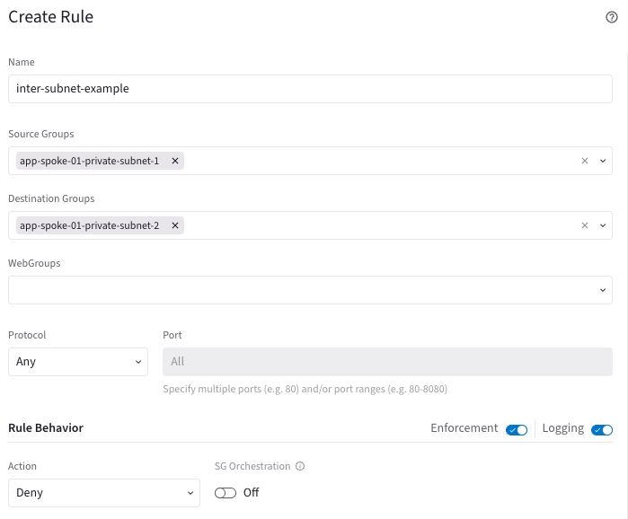
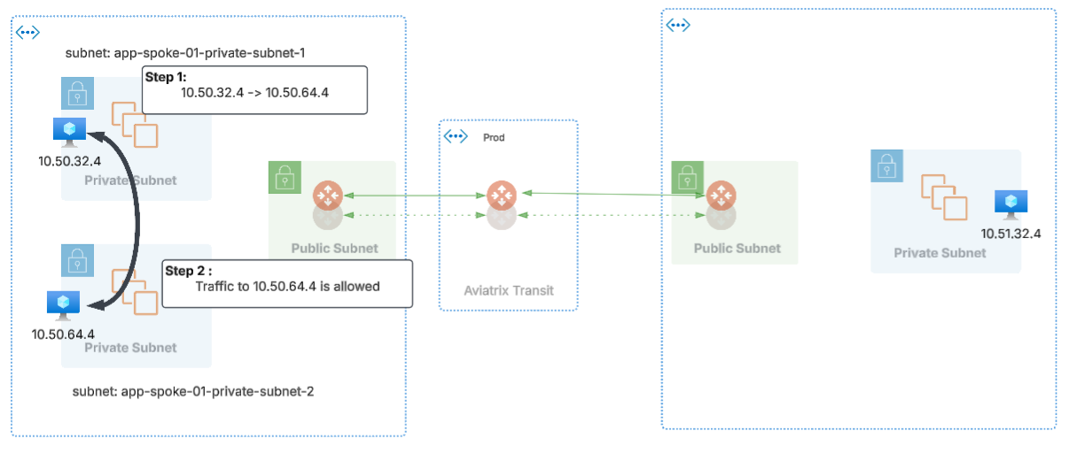

Example 2:
In this example, a rule is configured to block traffic from app-spoke-01-private-subnet-1 to app-spoke-01-private-subnet-2. This rule DOES have Security Group Orchestration enabled. As a result, traffic is blocked.

If INTRA-VNET filtering is required, ensure that SGO is enabled on the rule.
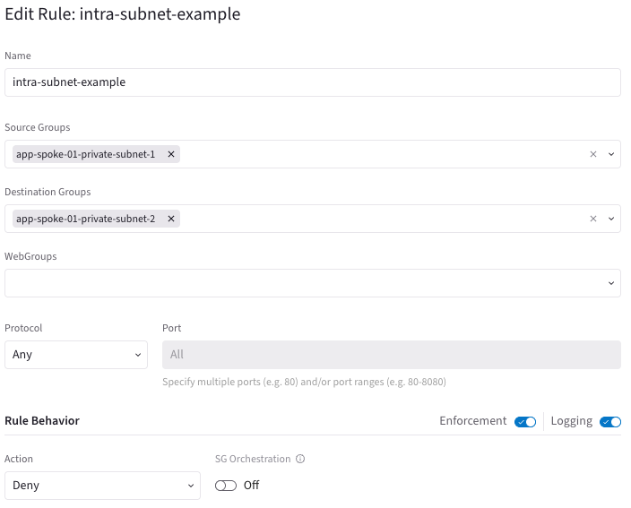
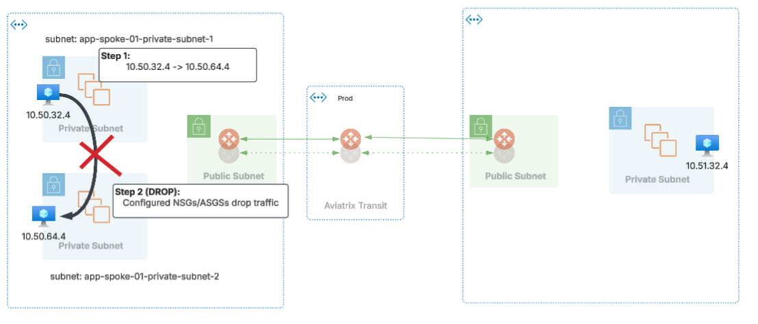

Example 3:
In this example, a rule is configured to block traffic between app-spoke-01-private-subnet-1 and app-spoke-02-private-subnet-1. This rule has SGO enabled.
The important thing to note is that Aviatrix will block INTER-VNET traffic at the spoke gateway as opposed to using an Azure NSG. This provides additional visibility not available in NSG rules alone.
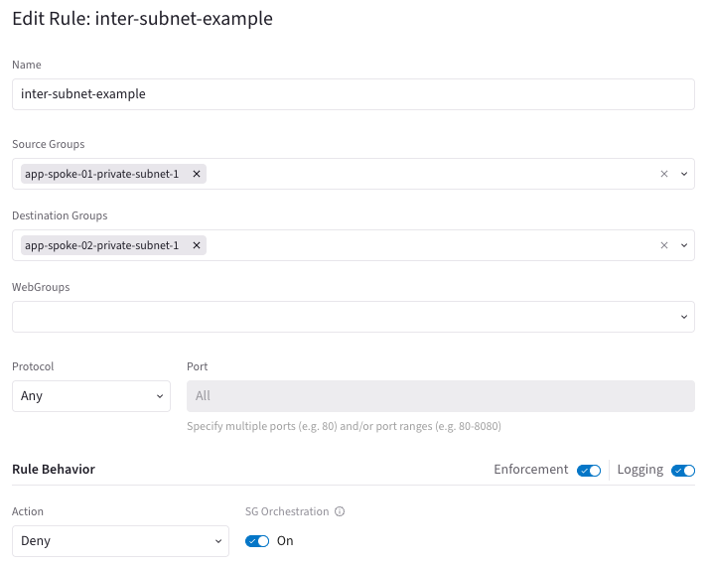
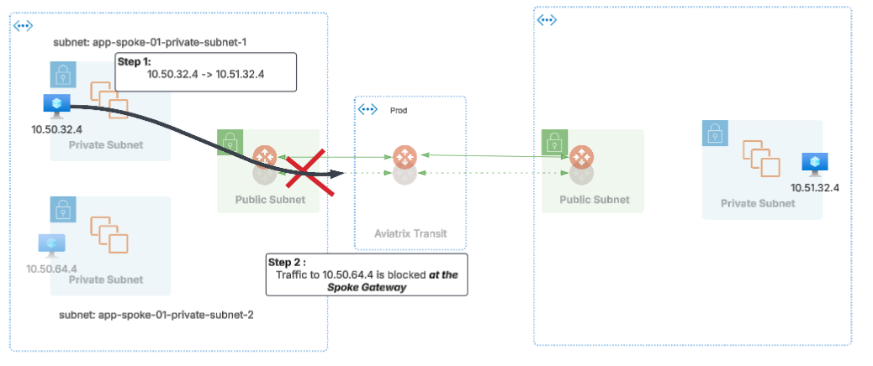

Example 4:
In this example, a rule is configured to block traffic between app-spoke-01-private-subnet-1 and Anywhere (0.0.0.0/0). This rule has SGO enabled.
The important thing to note is that Aviatrix will block INTER-VNET traffic at the spoke gateway as opposed to using an Azure NSG. This provides additional visibility not available in NSG rules alone.
In addition, Aviatrix will block INTRA-VNET traffic by means of an Azure NSG/ASG.
This is an example of how Aviatrix intelligently programs firewall policy throughout the environment.
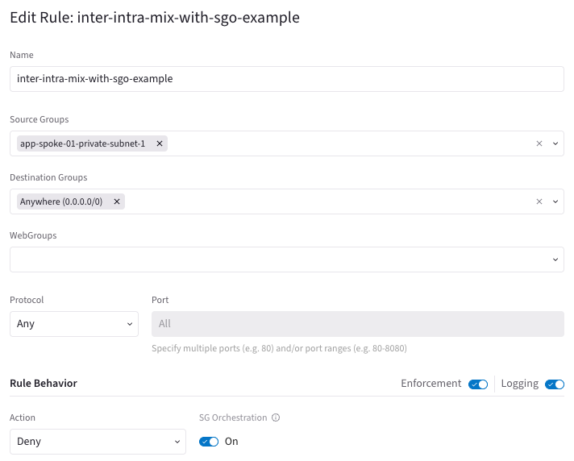
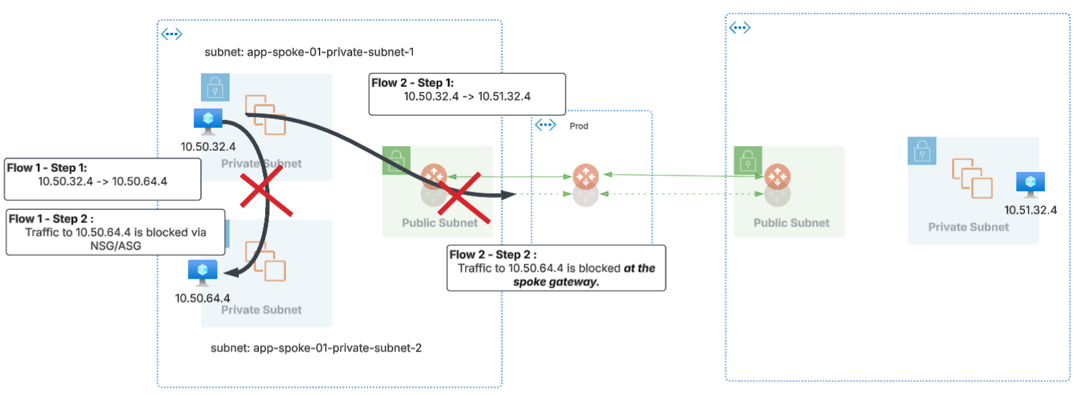

Network Address Translation and DCF
Aviatrix provides the ability to perform Network Address Translation (NAT) on traffic that passes through an Aviatrix Gateway. When combined with Aviatrix Distributed Cloud Firewall rules, the rules at each gateway are applied prior to NAT translation in the given direction.
Network Address Translation and Smart Groups
Aviatrix Smart Groups that use tags or properties will always resolve to the NON-NATed private IP address. This is important to note as we evaluate the behavior for DCF with SNAT and DNAT configurations.
For example, a smart group based on a VM name will resolve the actual IP addresses associated with the VM. An easy way to determine what IP addresses Aviatrix DCF will use for the Smart Group Object is to look at the group preview screen after enabling the IP address column:
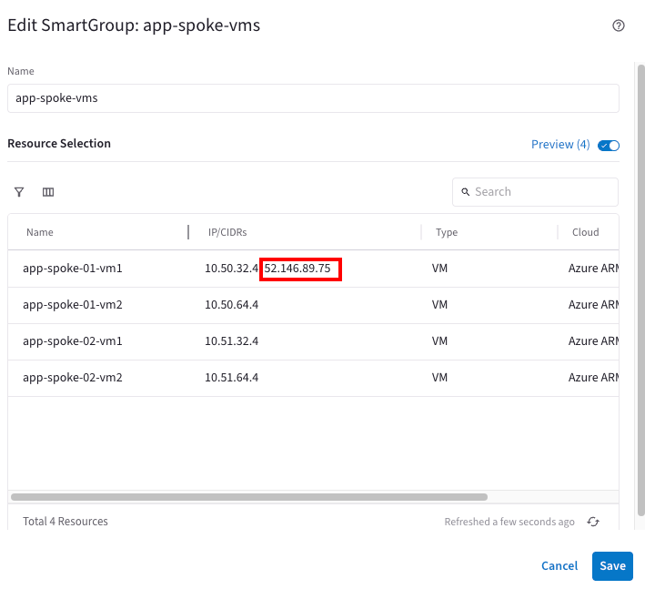

Source NAT (SNAT)
Example 1:
In our first example, a spoke gateway is configured to SNAT all traffic flowing through it to 5.5.5.5. A DCF rule is configured to block all traffic destined to 5.5.5.5. As a result, traffic flows from the source spoke network to the destination spoke network and is SNATed to 5.5.5.5. The response traffic (destined for 5.5.5.5) is blocked as per the configured rule:
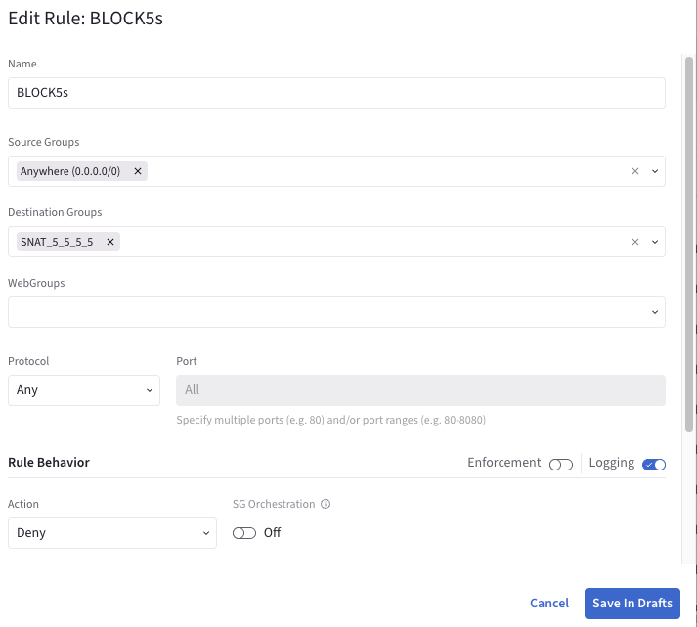
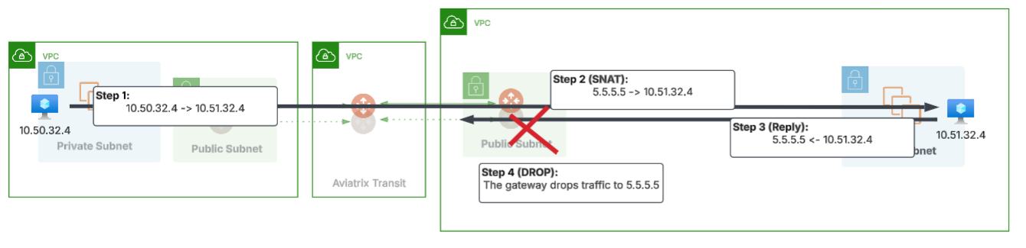

Example 2:
In our second example, we have the same SNAT configuration as seen in example 1. A spoke gateway is configured to SNAT all traffic flowing through it to 5.5.5.5. We’ve updated the DCF rule to block all traffic destined to 10.50.32.4.
As a result, traffic flows from the source spoke network to the destination spoke network and is SNATed to 5.5.5.5. The response traffic (destined for 5.5.5.5) is allowed and upon flowing through the gateway is un-NATed back to the original source destination (10.50.32.4). The traffic is then forwarded to the destination spoke.
The destination spoke however sees that this traffic is to be blocked and drops the traffic.
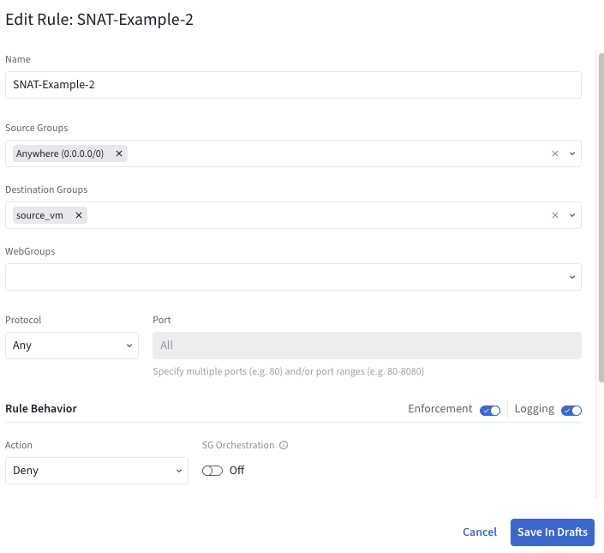
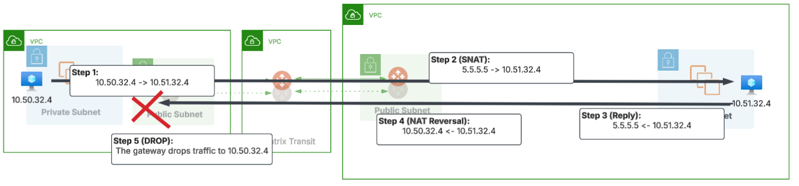

Destination NAT (NAT)
@todo

Layer 7 Filtering
Aviatrix supports the egress filtering of HTTP and Implicit TLS protocols in the Aviatrix Distributed Cloud Firewall. Explicit TLS is traffic that is TLS encrypted from the beginning of the flow. Examples of TLS are HTTPS and SSH traffic. Note that STARTTLS which is commonly used in SMTP, POP3, and IMAP is NOT supported with Layer 7 filtering at this time.
Example 1:
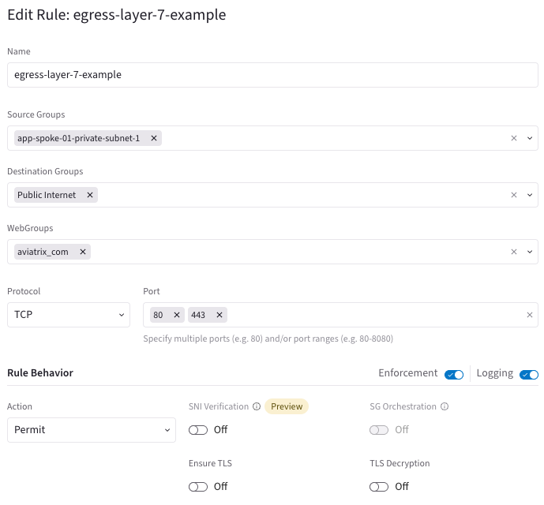
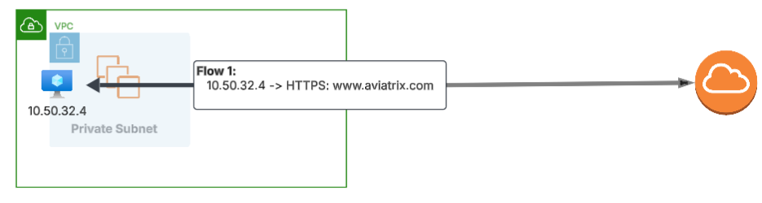

It is important to note that Aviatrix does NOT support the use of this Layer 7 filtering in East/West scenarios at this time.

Example 2:
In this example, a rule is created to perform Layer 7 filtering between VPCs. This configuration is NOT SUPPORTED by Aviatrix at this time.
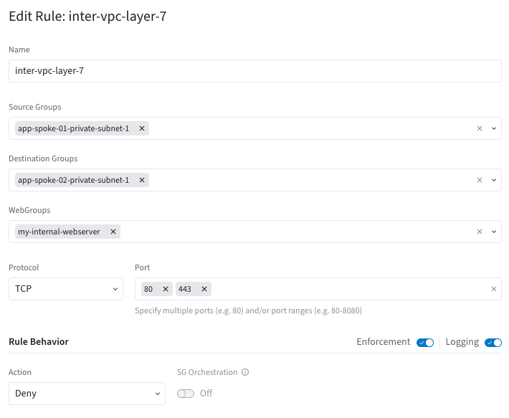
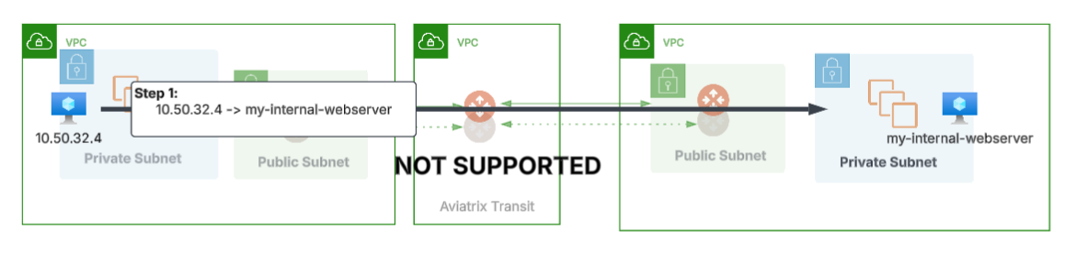

Example 3:
In this example, the VPC is configured with Aviatrix Secure Egress. A rule is configured so that ALL traffic to the Internet is inspected at Layer 7. While this may work in some instances (cases where the only Internet bound traffic is HTTP/HTTPS, etc) This is recommended against as it will likely cause issues with other application protocols.
When using Layer 7 features, ALWAYS explicitly set ports and protocols in the intended rules.
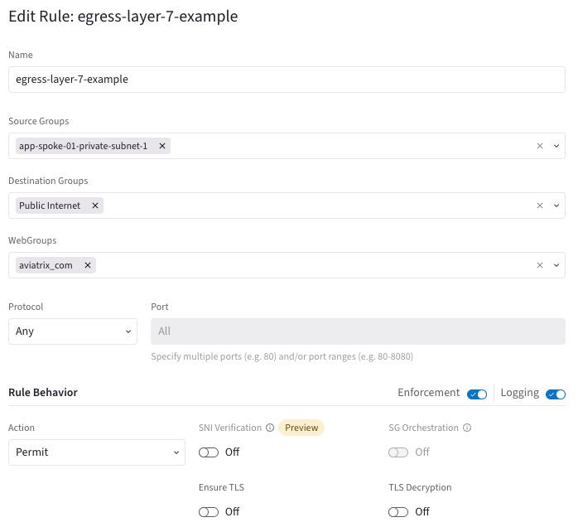
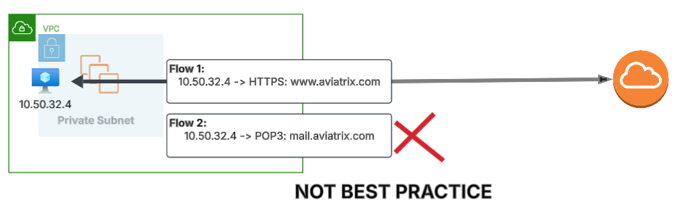

Additional Layer 7 features
Aviatrix also has a number of Layer 7 features to be aware of.

SNI Verification
SNI Verification validates the Server Name Identifier field seen from the client in the TLS handshake. When enabled on a rule, Aviatrix verifies the SNI value sent in the client hello matches the server certificate received from the upstream host. SNI verification is available only on PERMIT rules as an added means to verify host authenticity.
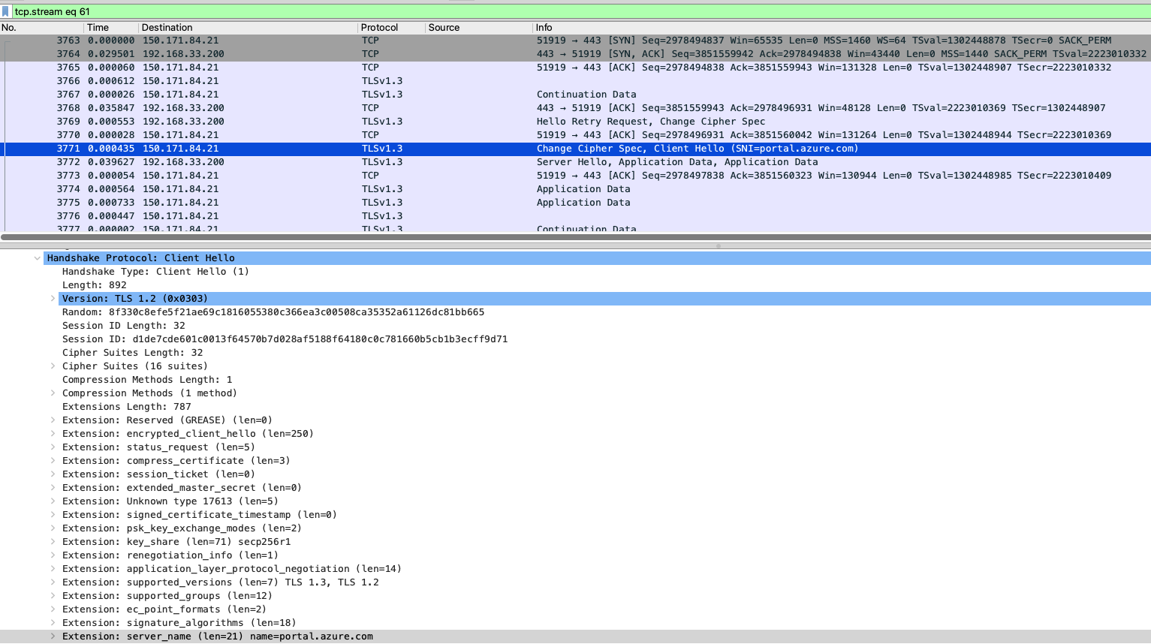

Example 1:
In this example, an egress web rule is configured with the optional SNI verification. As a result, Aviatrix confirms the client HELLO SNI information matches the certificate sent from the upstream server.
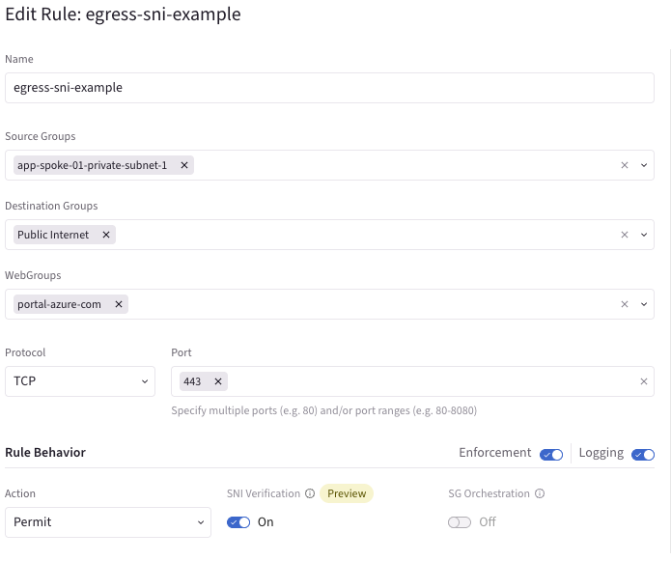
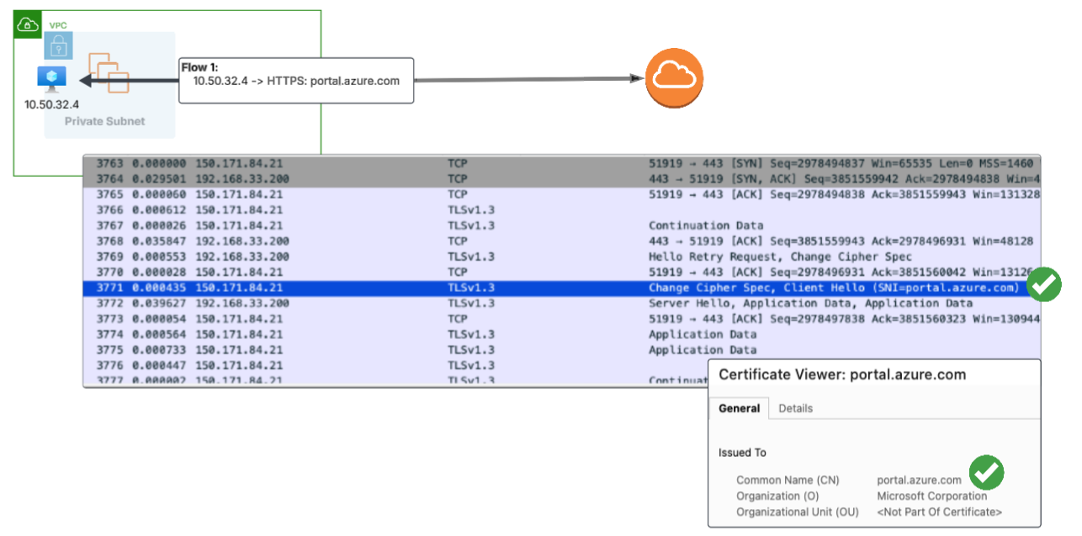

Ensure TLS
When enabled on a rule, Aviatrix ensures that the traffic matching the rule is properly encrypted with implicit TLS. Traffic that is not properly encrypted will NOT match the rule. This feature can be used to prevent accidental leaking of data in plaintext.

TLS Decryption
TLS decryption allows Aviatrix Gateways to decrypt TLS encrypted traffic destined to the Internet for additional inspection. This is commonly used in conjunction with Intrusion Detection (IDS) to identify malicious and questionable application behavior.

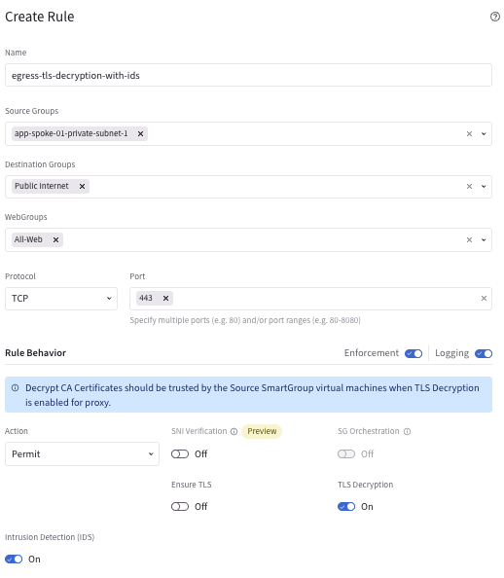

- Overlapping IP and how it’s handled.
  - (Smart groups match on all IPs)
- NAT handling
  - (Rules are applied pre-NAT)
  - Custom NAT
  - Mapped NAT
- External Connections Handling

Distributed Cloud Firewall Policy Best Practices
- Leverage Rulesets to provide granular ordering and control of firewall policy.
- Establish a ruleset ordering and rule numbering pattern to simplify rule creation.
- Set the Post Rules Policy List to block all non-defined items. See Brownfield Migration Pattern for examples of how to systematically shift to a DENY ALL posture.
- Separate Layer 4 rules by protocol when possible.
- When developing rules, it can be beneficial to insert specific rules to allow or deny traffic with logging enabled but enforcement disabled.
- Group Rulesets based on maturity level when possible.
- Rule activity is based on first-enforced-match.
Rulesets in CoPilot:
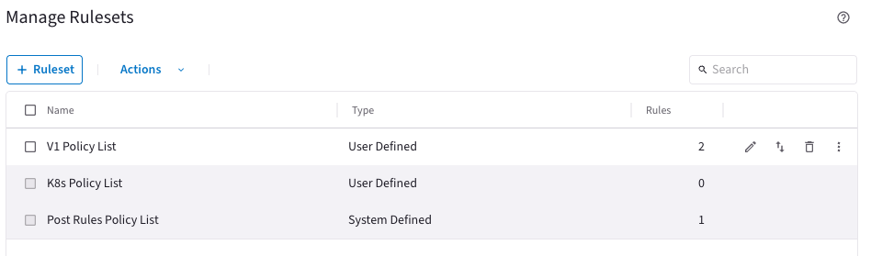
There are 3 default rulesets in Aviatrix 8.1 - V1 Policy List, K8s Policy List, and Post Rules Policy list. Users are encouraged to create and order their own policy lists to help improve management of firewall policy.

Example Policy Lists:
Rule Prefix | Purpose | Description
1x | Global IP Blacklist | IP ranges that are NOT allowed PERIOD. Leverage smart groups for this (Future: External Lists!)
5x | Global IP Whitelist | Whitelisted IP ranges that apply to ALL environments. This can be Public IP addresses.
100 | Threat Feeds | Place Threat Feed based controls after global whitelist
1,xxx | Noisy Traffic  (Scanners, etc) | Break the rules out in a way (by region, etc.) so that if you temporarily need to enable logging for troubleshooting, it becomes minimal
2,xxx | Shared Services | Break this out by service, if possible, but a large list is acceptable.
3,xxx | Brownfield VPCs Allow All | Start deployment with a Brownfield ALLOW for ALL traffic by VPC.  Gradually remove VPCs from the Brownfield ALLOW to move forward with rollout.
4,xxx | Application Traffic DENY Override | If there’s exceptions to what is normally allowed between environments, DENY them first.
5,xxx | Application Traffic  (matching Env/App Tags) | If PROD:WEBAPP1 should be able to talk to PROD:WEBAPP1 in other VPCs, put it here.
6,xxx | Application Traffic  (Inclusion Rules) | In addition to what’s normally allowed, here we define other items to include.  IE: NON-PROD-WEBAPP1 – PROD:DB1
7,xxx | Internet Bound L4 Rules | Separate Layer 4 rules from Layer 7 when possible. This will reduce gateway sizing needs.
8,xxx | Internet Bound L7 Rules | Define layer 7 rules prescriptively with protocols.  Be explicit (IE: TCP:443 vs ALL)

Develop Tagging Practices

Tagging resources is always a best practice when working in cloud environments. This provides the ability to quickly understand responsible parties, criticality of the deployed resources, and more.
When used with Aviatrix Distributed Cloud Firewall Smart Groups, security posture can be simplified – allowing workloads with matching tags an easy ability to communicate with each other. For example, simple rules can be established allowing “Production App1” to talk with any other resources tagged “Production App1”.
The following guidelines can help establish an Enterprise wide tagging posture:

Guideline | Description
Be Consistent | Establish a controlled, centrally governed tag dictionary with standard key names and allowed values.
Be Descriptive | Clearly define environment (PROD, NON-PROD, etc).  Define Technical and Business owners.  Include Cost Center IDs, department emails etc.
Use Application Codes | Issue codes that define the application delivered.
Define Application Tier | In addition to Application Code, include tags that help define the purpose of the specific workload (Web, DB, etc)
Define Criticality | Defining criticality provides an understanding of the business impact of the resource.
Use Data Classification | When possible and if appropriate, define the classification of data by level.
Avoid Sensitive Information | Never store sensitive information in tags. Use department emails and cost centers vs. Personal information.

Brownfield Migration Pattern
In Brownfield environments, consider using a gradual approach to migrating to a DENY ALL posture vs simply switching the built in “Greenfield Rule” to DENY. This can be done a few different ways.

Approach 1: Enabling logging on Greenfield Rule
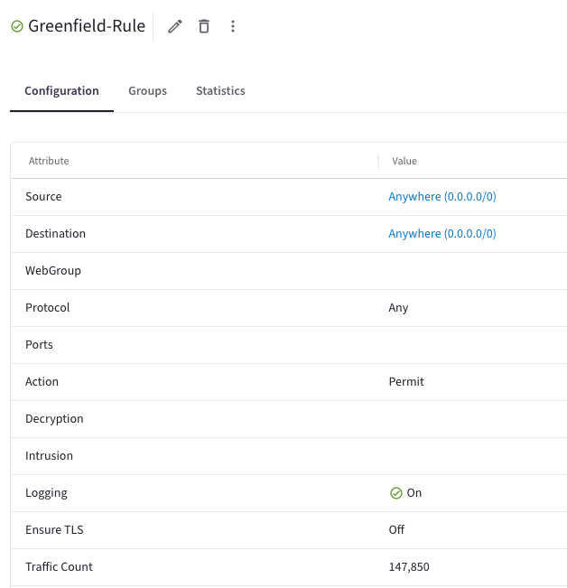
The built-in Greenfield rule (which matches any traffic which is not explicitly defined in DCF rules) to “PERMIT” with logging turned off. One can turn on logging briefly to help identify any traffic that does is not already accounted for. Specific rules can then be created to address the identified traffic.

Approach 2: Specific per-environment rule (safer approach)
A safer approach to identifying traffic that is not currently accounted for is to establish targeted smart groups to help in identification of non-matching traffic. For example, if you tag all of your development VPCs with the value pair “Environment” = “dev”, create a matching smart group.
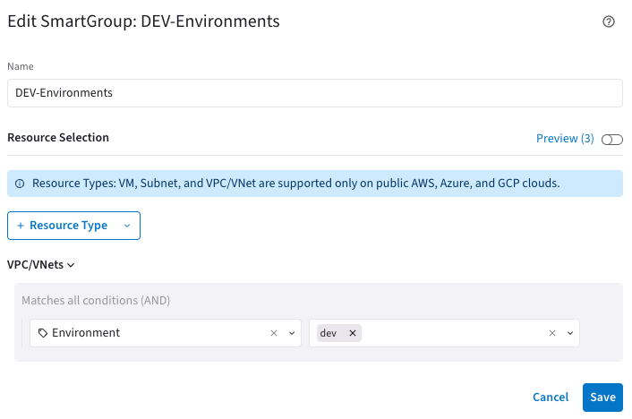
Next, establish NON-ENFORCED DENY rules with logging enabled to match on inbound and outbound. This rule is to be placed AFTER all of your allow rules for the DEV environment.
Finally, review logs for any traffic matching this rule. After a period of monitoring, enforce the rules to block non-defined traffic in the DEV environment.
Once all environments are accounted for, the Greenfield rule can be set to an ENFORCED DENY.

Terraform Deployment
All of Aviatrix DCF can be configured by means of Terraform. A JSON based engine is available for quick deployment of many features here. This allows organizations to simply place JSON files in a configuration directory and apply Terraform – enabling faster automation and integration of DCF.

Firewall Migration
Aviatrix Professional Services has the ability to migrate earlier Aviatrix features as well as other vendor configurations to Aviatrix using the DCF Policy Translator. If interested, reach out to your account executive for more information.

